SAN DIEGO SEND-OFF
Thursday, February 29th, 2024

If you are receiving this email, it is because you are a client and/or friend of the La Jolla Private Wealth Group of Wells Fargo Advisors. The idea behind the San Diego Send-Off is to keep you abreast of interesting trends we are seeing in the market/world.

Best Regards,

Robert Palatella Michael O’Brien Josh O’Brien, CFP®, SE-AWMA™ Melanie Gilmore, CRPC®, AWMA®
Managing Director Private Wealth Financial Advisor First Vice President Financial Advisor Senior PIM Managing Director Josh.obrien@wfa.com Melanie.gilmore@wfa.com
Portfolio Manager Senior PIM
Robert.palatella@wfa.com Portfolio Manager
Michael.j.obrien@wfa.com

La Jolla Private Wealth Group: 2024 Forbes Best-In-State Wealth Management Teams. The Forbes Best-In-State Wealth Management Teams rating algorithm is based on the previous year’s industry experience, interviews, compliance records, assets under management, revenue and other criteria by SHOOK Research, LLC. Investment performance is not a criterion. Self-completed survey was used for rating. This rating is not related to the quality of the investment advice and based solely on the disclosed criteria. Fee paid for use of logo.

U.S. stocks and bonds historically have performed well following the end of a Fed rate hike cycle
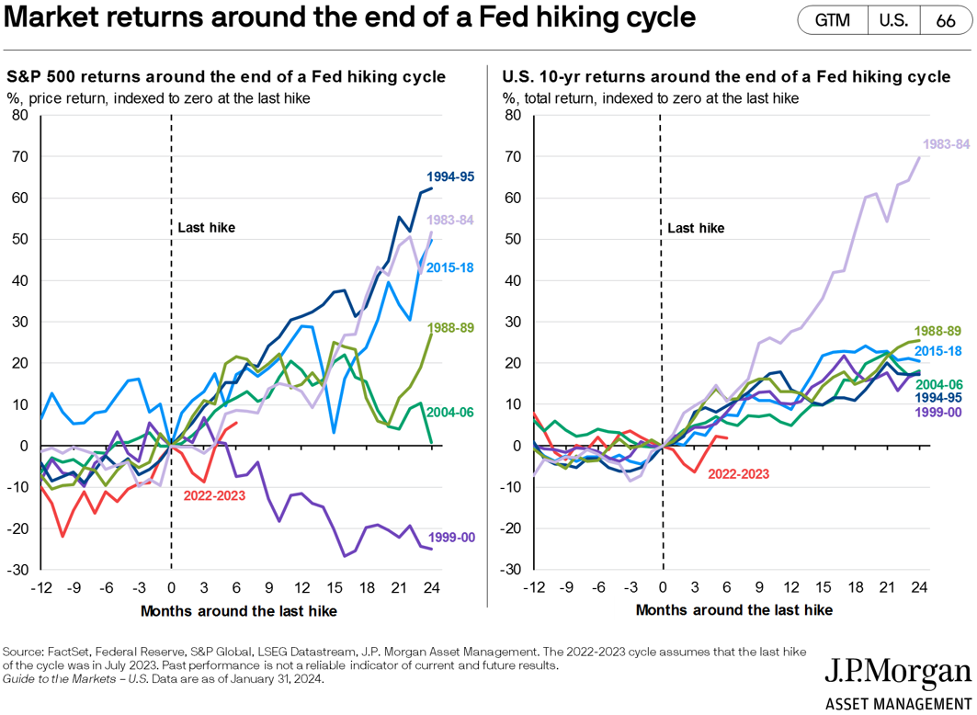
According to Zillow, home prices rose 3.2% between Dec 2022 and Dec 2023
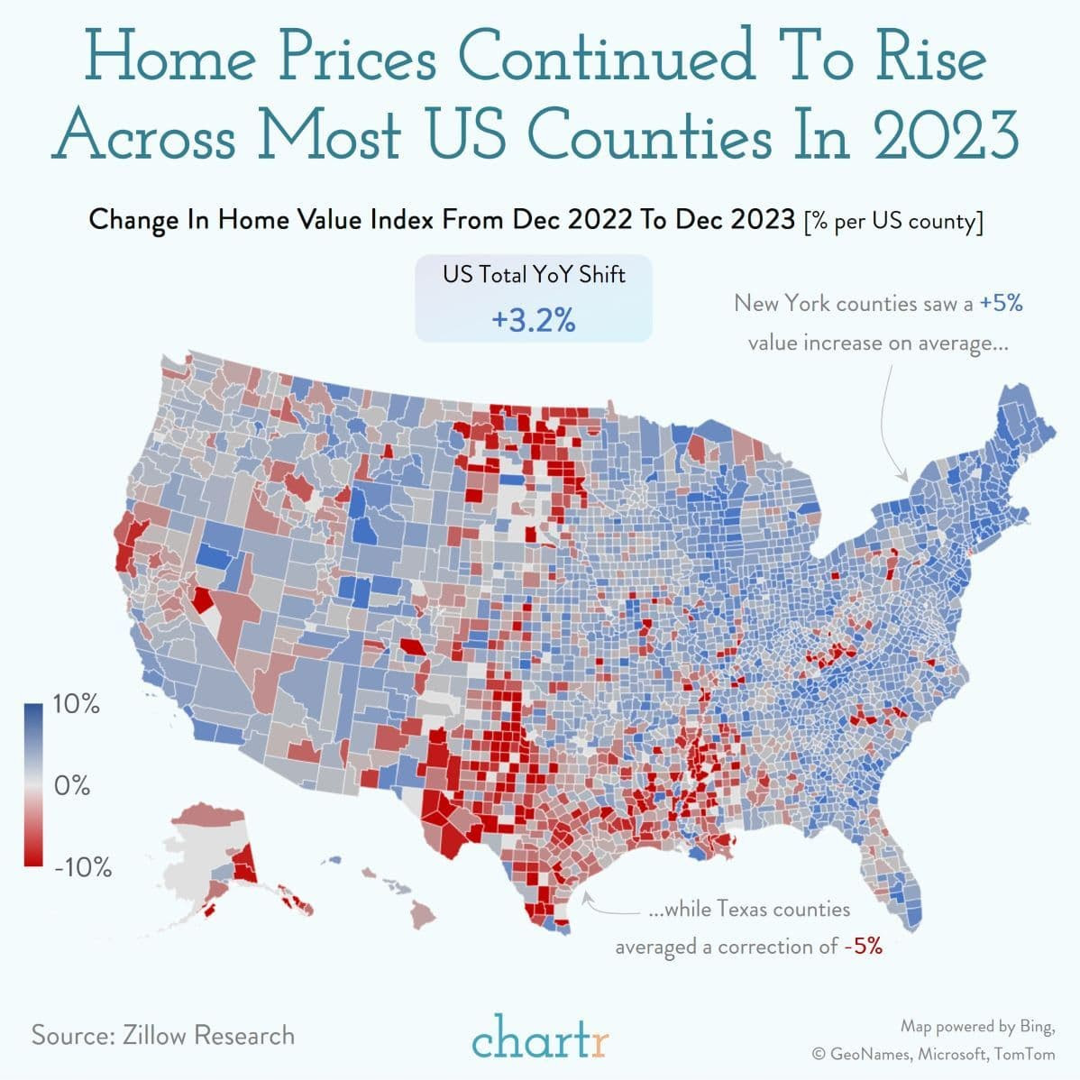

Integration of AI into digital advertising remains a potential growth driver for streaming providers
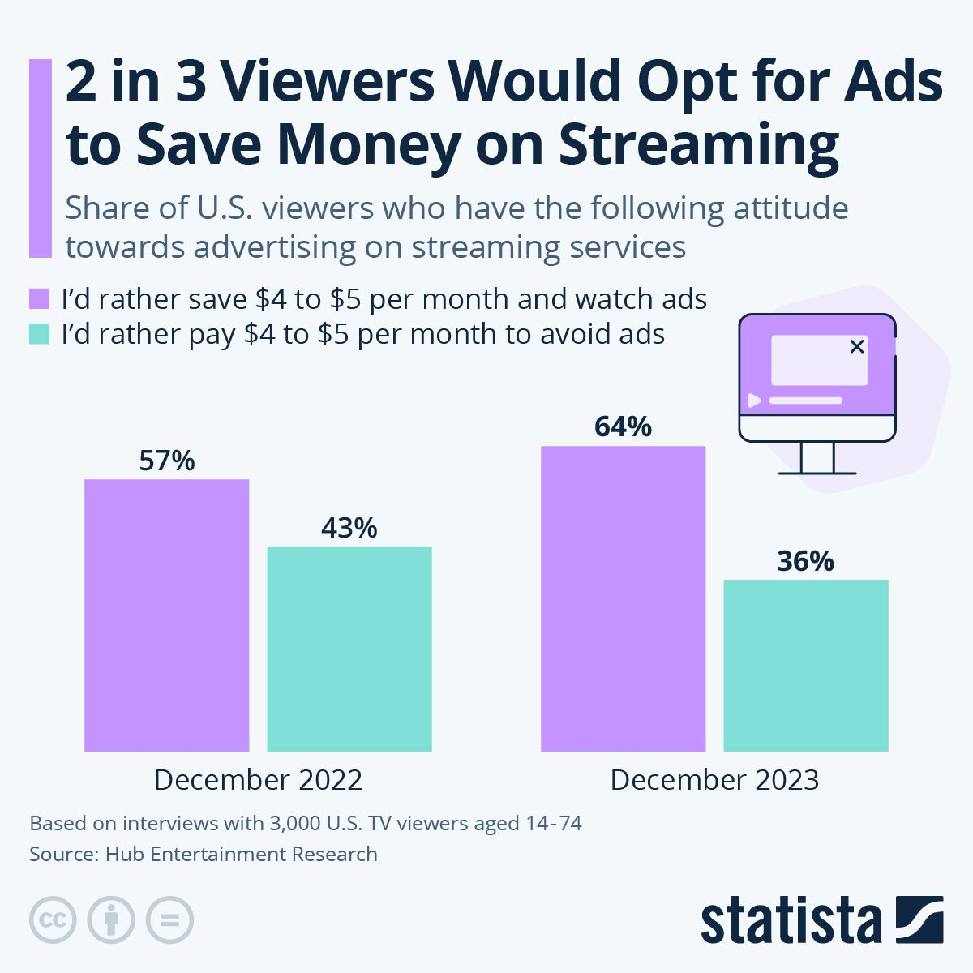
The risk/reward of owning bonds has improved with high current interest rates

Sources: Bloomberg and Wells Fargo Investment Institute, as of December 31, 2023. For illustrative purposes only. T-bills (Treasury bills): Bloomberg U.S. Treasury Bills (1–3M) Index, Investment-grade (IG) taxable fixed income: Bloomberg U.S. Aggregate Bond Index. IG corporates: Bloomberg U.S. Corporate Bond Index, High yield: Bloomberg U.S. Corporate High Yield Bond Index, Asset-backed securities: Bloomberg U.S. Asset Backed Securities Index, Mortgage-backed securities: Bloomberg U.S. Mortgage Backed Securities Index, Municipals: Bloomberg Municipal Index. Yields represent past performance and fluctuate with market conditions. Current yields may be higher or lower than those quoted above. An index is unmanaged and not available for direct investment Past performance is no guarantee of future results. See index definitions on following page. Bonds are subject to market, interest rate, price, credit/default, liquidity, inflation and other risks. Prices tend to be inversely affected by changes in interest rates. High-yield fixed-income securities are considered speculative, involve greater risk of default, and tend to be more volatile than investment-grade fixed-income securities. Although Treasuries are considered free from credit risk they are subject to other types of risks. These risks include interest rate risk, which may cause the underlying value of the bond to fluctuate. In addition to the risks associated with investment in debt securities, a fund’s investments in mortgage-backed and asset-backed securities will be subject to prepayment, extension and call risks. Municipal bonds are subject to credit risk and potentially the Alternative Minimum Tax (AMT). Quality varies widely depending on the specific issuer. Municipal bonds offer interest payments exempt from federal taxes, and potentially state and local income taxes. Municipal securities are also subject to legislative and regulatory risk which is the risk that a change in the tax code could affect the value of taxable or tax-exempt interest income.

Texas, South Carolina, and Florida saw the largest population growth from 2022 to 2023
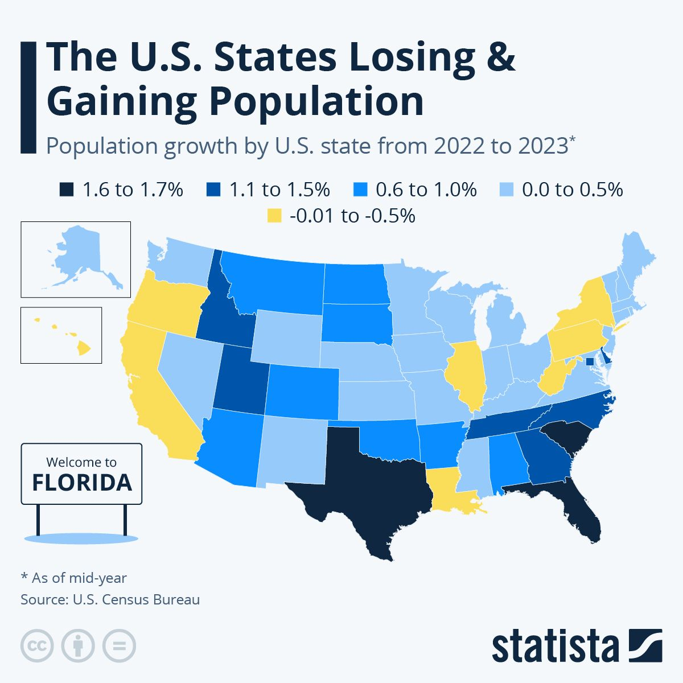

A 30-second ad during the Super Bowl costed $7 million in 2024
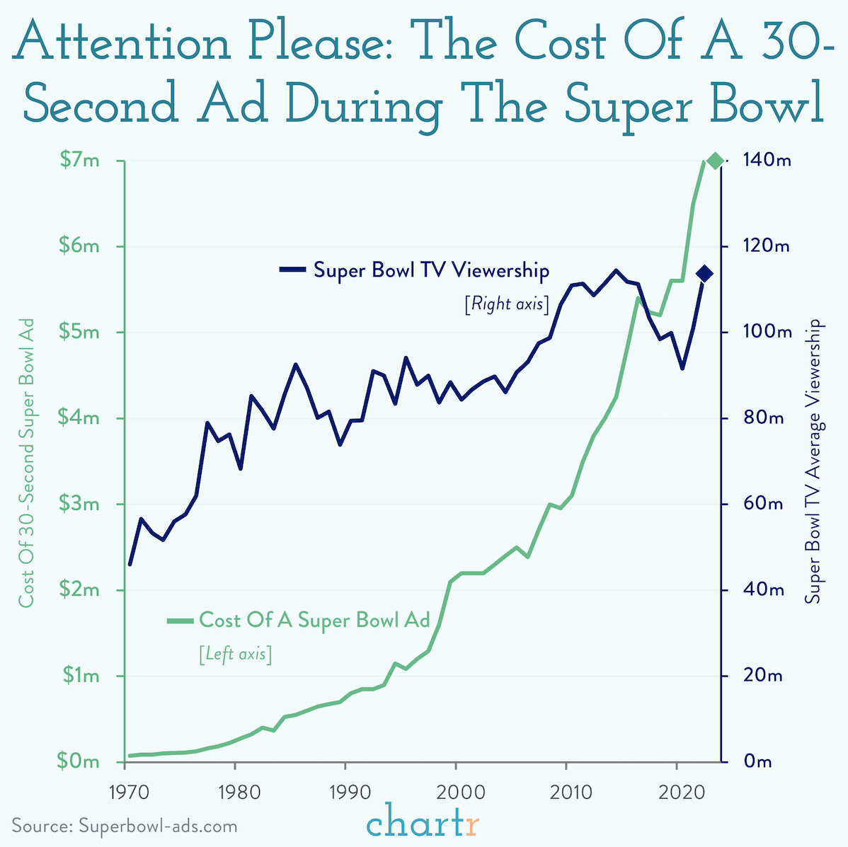
4 in 10 American adults say they’re almost always online, up from just 24% in 2015

Rising rates coupled with low supply has led to the most unaffordable housing market in decades

Sources: Bloomberg, U.S. Census Bureau, and Wells Fargo Investment Institute. Monthly data from January 1, 2007 to November 30, 2023. NAHB/Wells Fargo Housing Market Index: monthly data from January 1, 2007 to December 31, 2023. NAR Housing Affordability Index: monthly data from January 1, 2007 to October 31, 2023. SAAR = seasonally adjusted annual rate. NAHB (National Association of Home Builders)/Wells Fargo Housing Market Index is a widely watched gauge of the outlook for the U.S. housing sector. The NAR (National Association of Realtors®) Housing Affordability Index measures whether or not a typical family could qualify for a mortgage loan on a typical home.

According to the Department of Health, physical activity has the highest correlation with a longer life
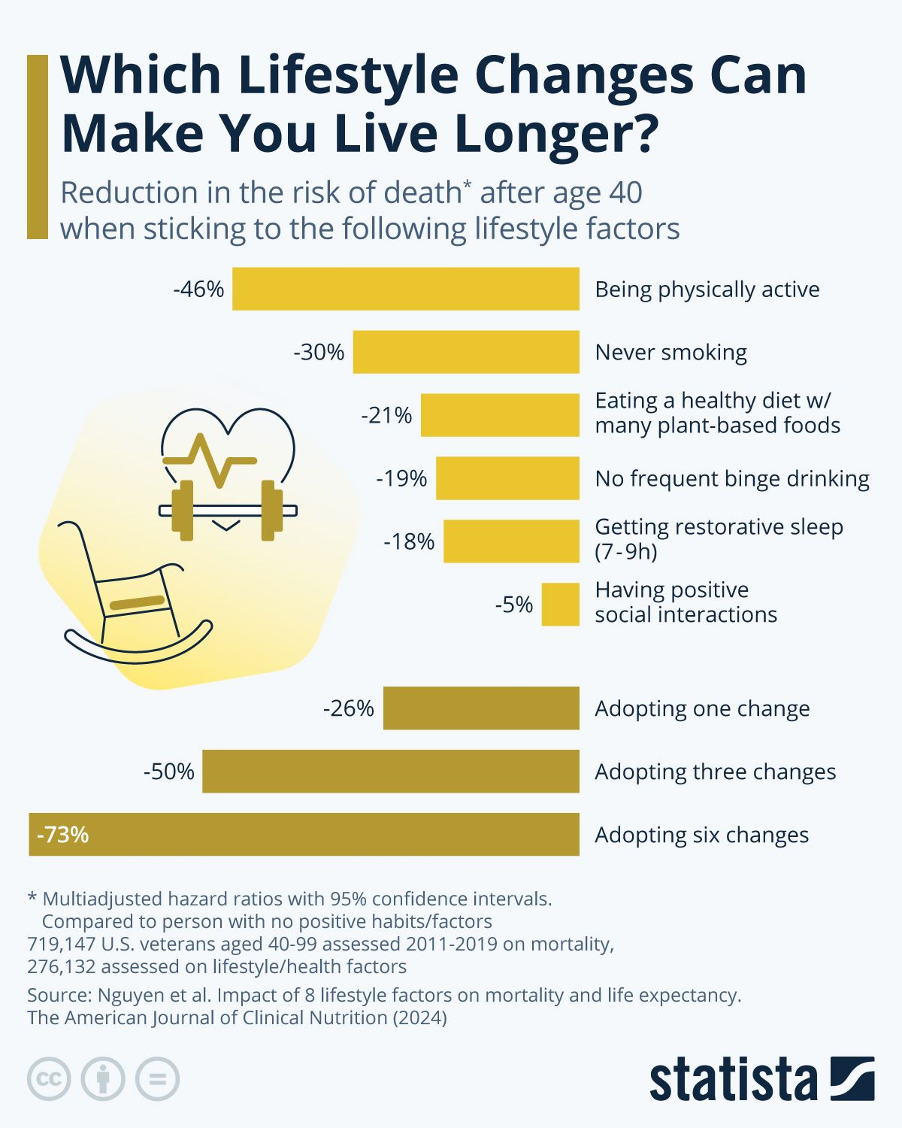
Articles of the month:

Tax law changes: What happens in 2024 and beyond?
Click Here to Read

So, you want to buy a sports team? Here’s how
Click Here to Read

The opinions expressed here reflect the judgment of the author as of the date of the report and are subject to change without notice. The material has been prepared or is distributed solely for information purposes. Please note that we are not responsible for the information contained on the listed web site(s). The site(s) is/are provided to you for informational purposes only.

